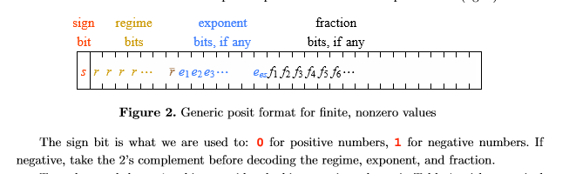

num1

num2

If num1 or num2 is negative, change it into 2’s complement (required by the format). Check whether they are zero store in isZero. Check whether one of them is infinite. If one of them is infinite, set isInf to 1.

Use LZC(leading zero counter) to get the length of regime bits

temp2[31:0]

isZero_1

isInf_1

temp1[31:0]

unum1_shift

Unum2_shift

Leftshift two numbers to make exponent bits and fraction bits in certain position.

Calculate the exponent value (in 2’s complement) by using exponent bits and the length of regimes bits

Temp2_2

Expo_num2

Compare_abs_2

Temp1_2

isInf_2

Expo_num1

Store the exponent number of the larger number in expo_numo (expo_numo=max(expo_num1, expo_num2)). And store the difference between two exponent values. (if absolute value of number1 greater than absolute value of number2: expo_num1>=expo_num2, diff_expo=expo_num1-expo_num2 . Vice versa) If the number is not zero, the fraction will be *1.fraction*, if is zero, will be 0.00000…00

Compare the absolute value of two numbers.

Compare_abs_3

Frac_num2_3

Expo_numo

Diff_expo

isInf_3

Frac_num1_3

Right shift the fraction of the number with smaller absolute value. Shift diff_expo bits.

Frac_num1

isInf_4

Frac_num2

Expo_numo

LZA(leading zero anticipator) is designed based on *Leading-zero anticipator (LZA) in the IBM RISC System/6000 floating-point execution unit* (http://ieeexplore.ieee.org/document/5389860/)

LZC(leading zero counter) module is designed based on MODULAR DESIGN OF FAST LEADING ZEROS COUNTING CIRCUIT (http://iris.elf.stuba.sk/JEEEC/data/pdf/6_115-05.pdf)

frac_shift_5

IsZero_6

Expo_numo_6

Frac_num2_4

Expo_numo

Manipulate zero, Inf and do the rounding

Right shift the number following the exponent value to add the regime bits on the left side

Normalize frac_numo by using LZA. Check whether the result is zero

Add frac_num1 and frac_num2. (in 1’s complement)

Use LZA (leading zero anticipator) to estimate the amount of shift

Unumo

isInf_7

Round

isInf_6

Frac_numo_6

Frac_numo_5

Expo_numo

isInf_5

Runumo

Runumo

isInf_4

Frac_num1_2